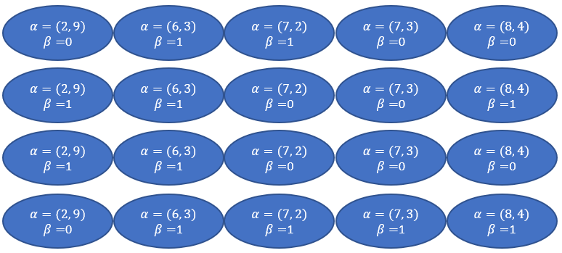

Figure 6. Four chromosomes are created in initialize phase